Louis Rozencwajg-Hays, Nicholas Gattuso, Kexian Wu

I pledge my honor that I have abided by the Stevens Honor System.

Experimentation and analysis of results

Case 1:

Initial scenario

Algorithm: FCFS

./assign1 4 4 100 10 0 0 123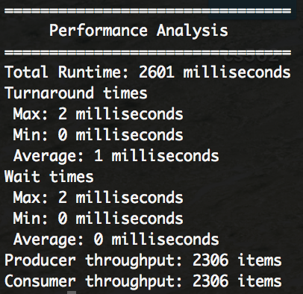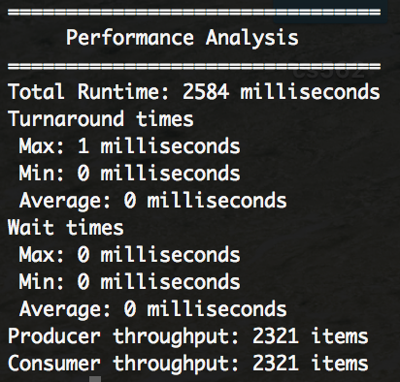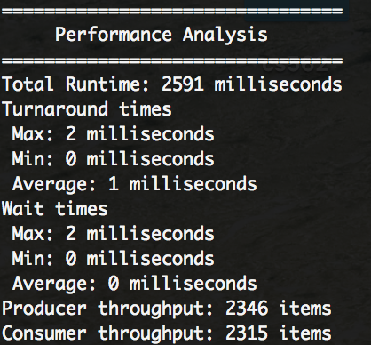

Case 2:

Lots of producers

Algorithm: FCFS

./assign1 2000 4 100 10 0 0 123

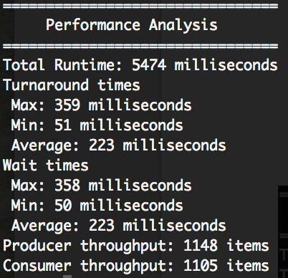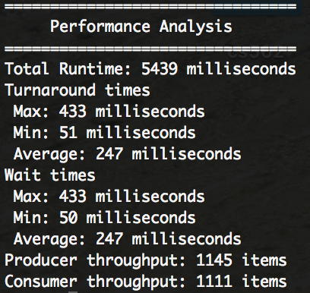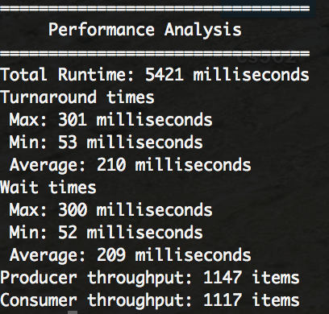

Case 3:

Lots of consumers

Algorithm: FCFS

./assign1 4 2000 100 10 0 0 123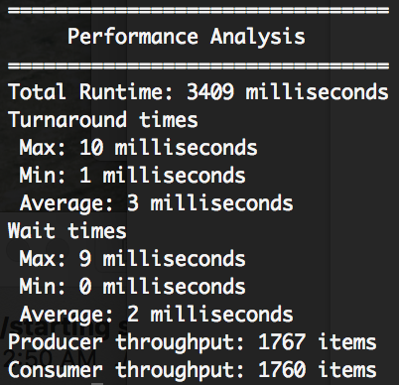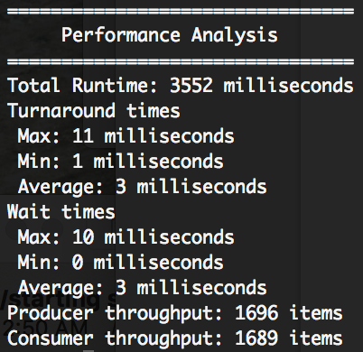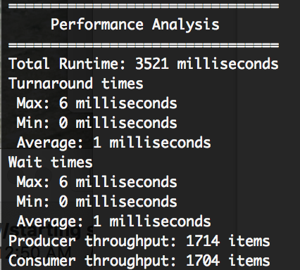

Case 4:

Lots of Products

Algorithm: FCFS

./assign1 4 4 1000 10 0 0 123

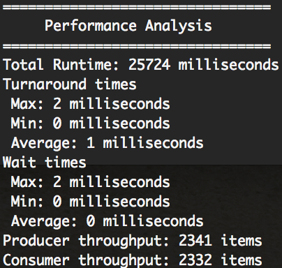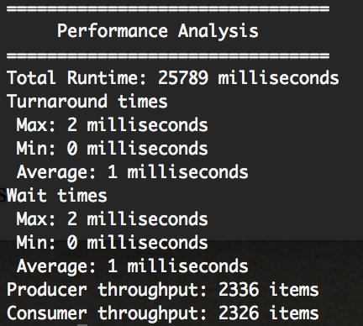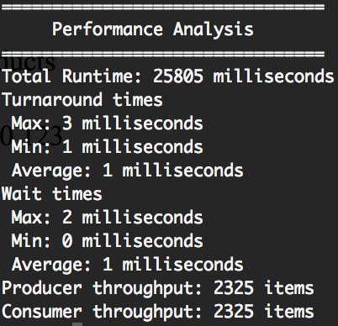

Case 5:

Small number of Products

Algorithm: FCFS

./assign1 4 4 50 10 0 0 123

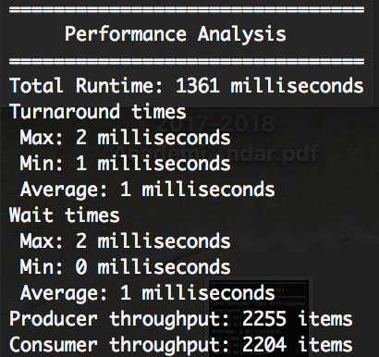

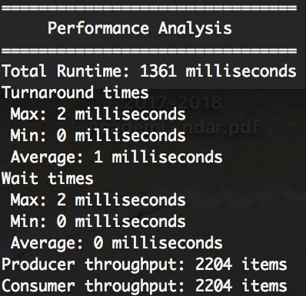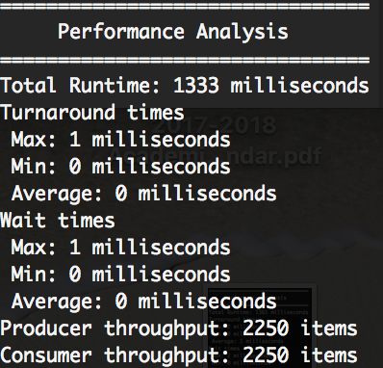

We observed that more products to produce, more times needed for the program to finish.

Case 6:

Initial scenario (very large quantum)

Algorithm: RR

./assign1 4 4 100 10 1 1024 123

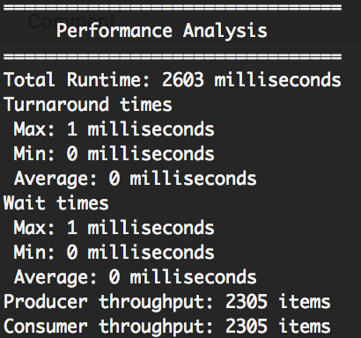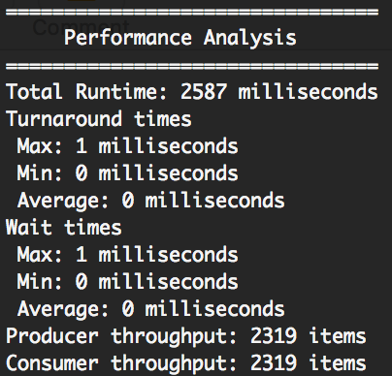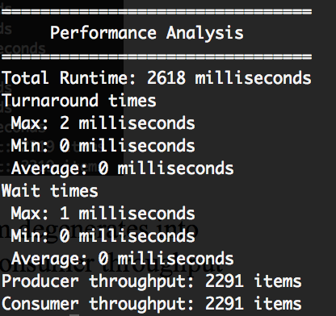

When the quantum approaches the maximum possible life, the long quantum degenerates into FCFS. The consumer throughput is approximately equal to producer throughput, but consumer throughput is bounded by producer throughput.

Case 7:

Small quantum

Algorithm: RR

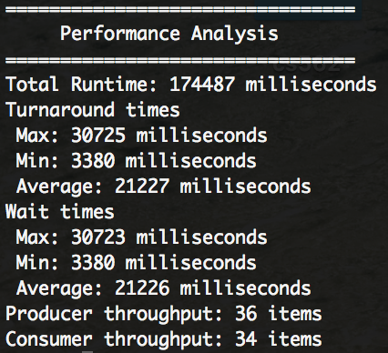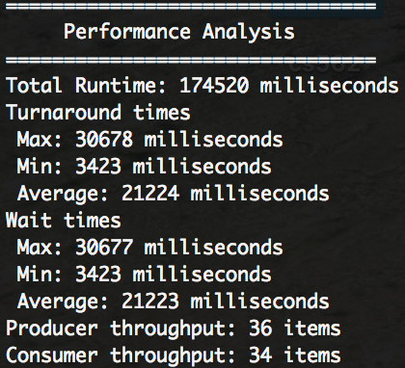./assign1 4 4 100 10 1 8 123

We observed that if the quantum is very low, the throughput is also very slow.

Case 8:

Lots consumer

Algorithm: RR

./assign1 4 2000 100 10 1 1024 123

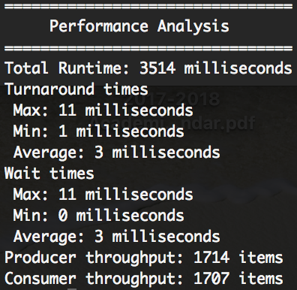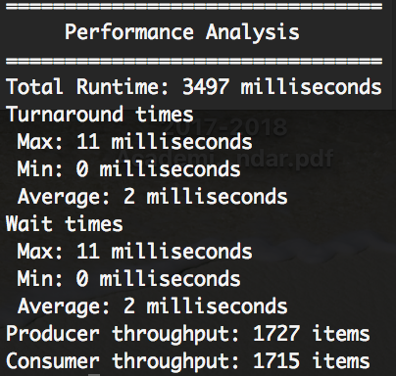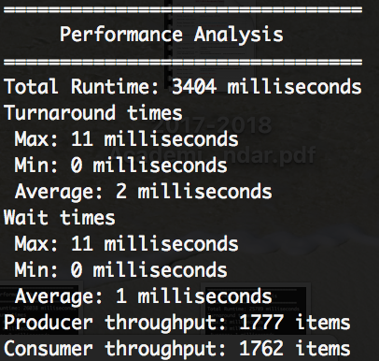

By comparing case 1 and case 8, we observed that the RR algorithm has a much faster wait time then FCFS algorithm when there are a large number of consumers.

Case 9:

lots of products && large quantum

Algorithm: RR

./assign1 4 4 1000 1 1 512 123

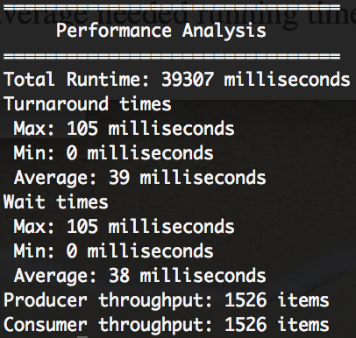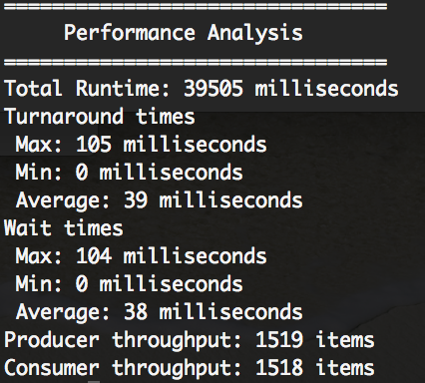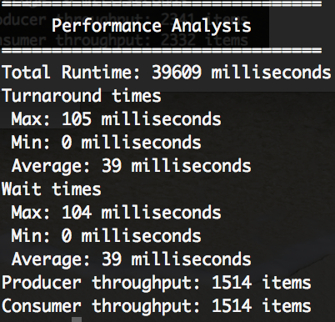

By comparing case 4 and case 9, we observed that FCFS is significantly faster than RR for both average turnaround time and average wait time when the number of products is large and quantum time equals to average life time.

Case 10:

Lots of producers && small quantum

Algorithm: RR

./assign1 2000 4 100 10 1 8 123

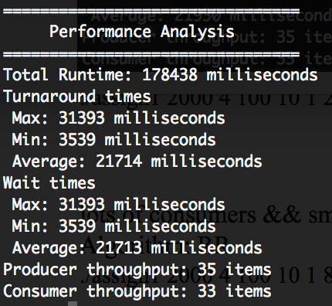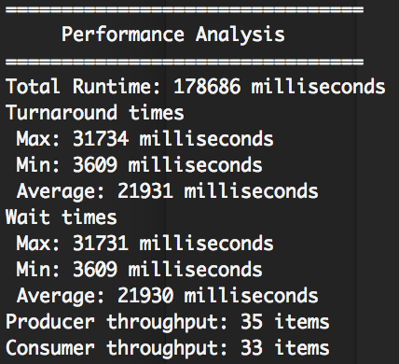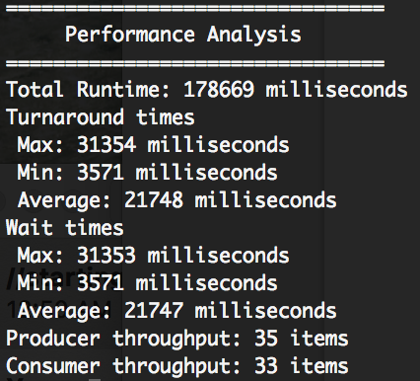

Case 11:

lots of consumers && small quantum

Algorithm: RR

./assign1 4 2000 100 10 1 8 123

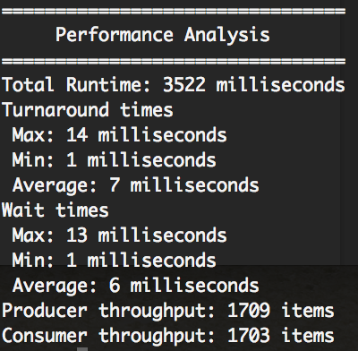

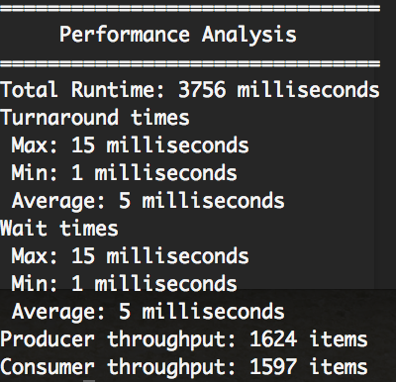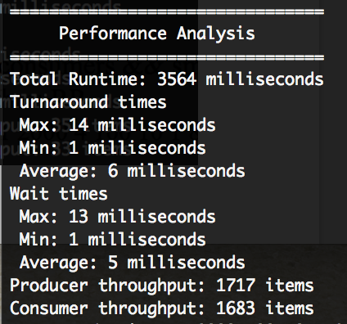

Case 12:

lots of consumers && large quantum

Algorithm: RR

./assign1 4 2000 100 10 1 512 123

